

**Sunday 3rd March, 2019**

**Join us at Tilgate Park & Tilgate Forest, Crawley for a Regional event (level C) - a mixture of fun, fast and technical areas for all abilities from Yellow to Brown.** **Also incorporating the 2019 Yvette Baker SE Trophy and Shield heats junior competition.**

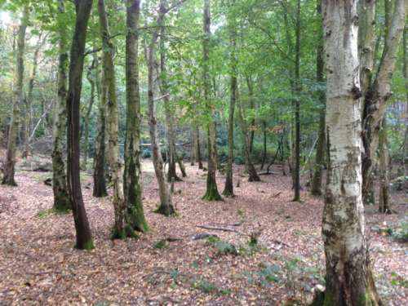Easily accessible from the M23/A23 by taking the Pease Pottage exit and following the brown tourist signs to Tilgate Park. Parking: TQ276345, Postcode: RH10 5PQ.

Lots to do in the Park including Nature Centre (small entry charges), children’s play area, Café, Pub, Walled Garden with maze, GoApe.

**Use of Tilgate Forest for this event has been granted by kind permission of the Forestry Commission. Access is normally restricted to public rights of way. Please respect these restrictions at all other times.**

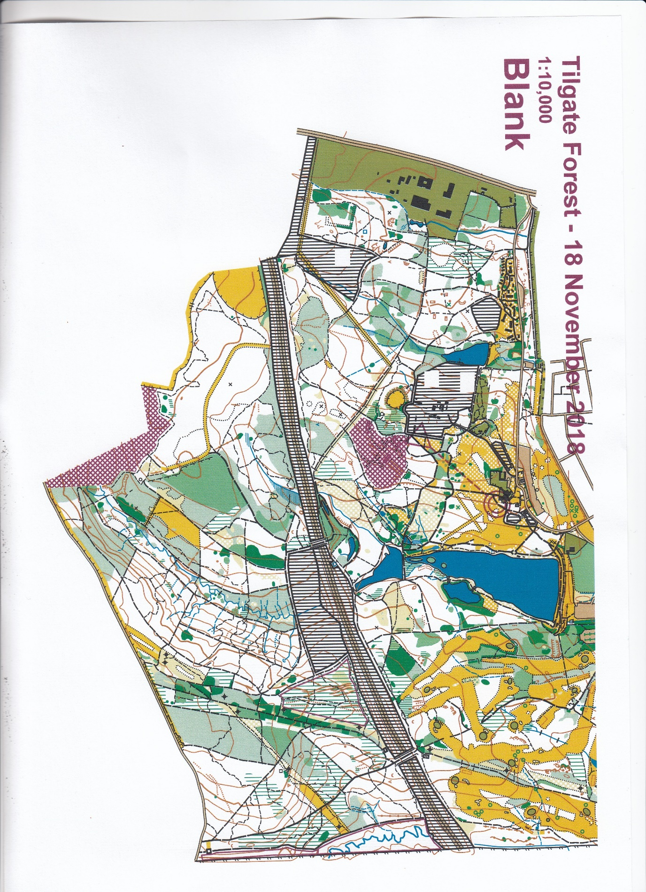The Start and Finish are within 400m of Assembly. We have a new map with survey and cartography by Neil Crickmore 2018. Drawn to ISOM 2017 using a LIDAR base map.

The event will use contactless SIAC electronic timing and also support non-contactless dibbers. Electronic timing dibbers available for hire.

Help will be available for newcomers. Toilets and first aid will be available. Dogs allowed but must be on leads around the Lake.

Registration: From 9.30am –11.30am.

Start times: 10.00am – 12 noon.

Courses close: 14.00pm. Turn up and run if pre-registered

|  |  |  |  |  |  |  |
| --- | --- | --- | --- | --- | --- | --- |
| **Pre-entry at fabian4.co.uk** | **BOF Sen** | **Other Senior** | **Orange & Yellow Sen** | **Orange & Yell Oth Sen** | **SO**  **Junior** | **Other Junior** |
| Up to 16/02/19 | £7 | £9 | £4 | £6 | Free | £3 |
| Up to 23/02/19 | £8 | £10 | £4 | £6 | Free | £3 |
| Up to 27/02/19 | £9 | £11 | £4 | £6 | Free | £3 |
| EOD | £10 | £12 | £4 | £6 | Free | £3 |

Dibber hire: £1 or £2 for contactless SIAC. Pay & Display parking.

Planner: Alan Williamson (SO), Organiser: Nick Care

Controller: Gordon Parker (SLOW)

Further info: <https://www.southdowns-orienteers.org.uk>

or contact Bridget Hooper on [membership@southdowns-orienteers.org.uk](mailto:membership@southdowns-orienteers.org.uk)